MIDTOWNERS SUNSHINE OF THE WEEK ► August 23rd, 2007
Birthday of PP Giridhar Lal Manandhar on August 26th

SPEAKER OF THE WEEK ► Dr. Pramod B. Shrestha
THEME | Cambodia: Images of a country (Past, Present and Future)
Prof. Shrestha completed his Masters of Science (M.Sc) course in Industrial Engineering and Management (1978) from England on a Colombo Plan Scholarship. On a CIDA fellowship (1991 – 1995), Prof. Shrestha completed his doctorate degree in Engineering Management from the University of Alberta, Canada.
At present, Dr. Shrestha is working as an International Consultant with an Asian Development Bank (ADB) funded Education Sector Development Project in Cambodia. He has been working as a Professor at the Institute of Engineering, Kathmandu, Nepal from 1975. From 2001 till 2003, he worked as a Governing Board-engaged Faculty Consultant at the Colombo Plan Staff College (CPSC) in Manila. Prior to his appointment at CPCS, Prof. Shrestha also served as the Director of the Center for Applied Research and Development (Nepal-Norway Project) at the Institute of Engineering from 1995 to 2001.
In 1999, His Majesty’s Government of Nepal awarded Prof. Shrestha with an “Education Day Medal” for his Meritorious Service at the Institute of Engineering and the students of the Institute of Engineering also selected him as the “Best Teacher” in 1998 and 1999. Prof Shrestha was also awarded letters of appreciation form the Government of Iran and Bhutan for his outstanding contribution in the field of Technical and Vocational Education during his service at the Colombo Plan Staff College in Manila.

UPCOMING SPEAKERS ► PREVIEW
DATE | SPEAKER | THEME
Aug 31st | Om Prakash Yadav  Award winning Nature Photographer | Dos and Don’ts when taking photos
Sept 7th | H.E. the Malaysian Ambassador to Nepal | Dinner Meeting
Sept 14th | PP William Ma | Orientation about Rotary

THE MID-TOWN CLUB ► NEWS
Last Week’s Speaker

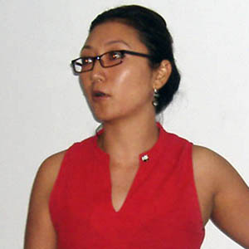

Guest Speaker Trishna Gurung from WWF Nepal talking about conservation activities

SCENES FROM LAST WEEK’S MEETING
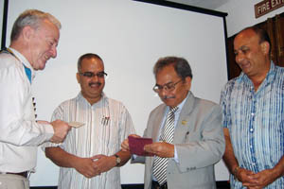 | 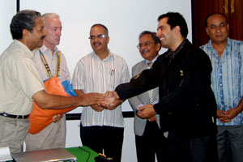
DGE Tika handing check from the Rotary Flood Disaster Relief Fund to Nepal Red Cross representative | CSD Pratap handing tarps to representative of Caritas Nepal
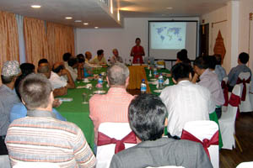 | 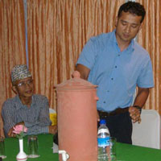
Members and Guests listening to the presentation | Rtn. Hem talking about the clean water project
SIGHT PROJECT
A workshop of "Sight Testing" was organized at Rotary hall Thapathali on 18th August 2007. The hosts clubs were Kathmandu Rotary & Rotaracts, Kathmandu Mid-Town Rotary & Rotaracts, and New Road City Rotaracts. The Professional Core group of Rotarian Ophthalmologists was the resource group. The workshop was attended by DGN Ratna Man Shakya and more than 100 Rotaracts from 13 clubs, Rotarian District Officials, Rotarians, DRR Anil and other Rotaract District Officials. Sight testing kits were distributed to each club courtesy of the resource group. The training program was conducted by Dr Chandra Lekha Tuladhar along with President Dr BK Malla and PP Dr OK Malla.

ROTARACT NEWS
Our Rotaracts observed Membership Month by inducting 4 new committed members into the club on August 16th. AG of Zone II Rtn. Purna Man Shakya was the chief guest at the program. The four new members are Gunjana Pandey, Namrata Dahal, Nimisha Poudel, and Kushmanjali KC.
Welcome to Mid-Town family !!!

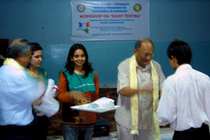 | 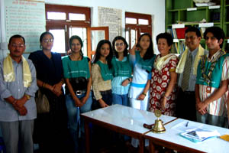
DGN Ratna Man Shakya handing out kits at the Sight Testing Workshop at Rotary Hall | Newly inducted Rotaracts with AG Purna Man Shakya, PP Dr. Lekha, Rotaract President Shekhar and guardians

Editor: Rabi Karmacharya, Club Service Director email: rabikarma@gmailcom

